Experimental Analysis of GAN Architectures on Fashion-MNIST (HA9 Report)
21194672 ZHANG Zimeng
1 Introduction
In this hands-on assignment, we did analysis of GAN’s performance on the Fashion-MNIST dataset.
The Generative Adversarial Network (GAN) is a model that can learn to generate data through adversarial training between a generator and a discriminator. However, it has weaknesses including training instability and mode collapse (the generator produces limited varieties of samples).
Fashion-MNIST, which is a difficult grayscale image dataset of ten clothing categories, is used in this assignment. We performed 16 controlled experiments, and used FID to compare the performance.
2 Experiment Settings
2.1 Running Pipelines
Training process iteratively optimizes generator and discriminator by adversarial learning, also tracking loss metrics and generating sample visualizations. In all experiments, we use MNIST as the dataset. It has 60,000 training images across 10 clothing classes, with each a 28×28 grayscale image. All images are normalized to [-1, 1], and training is performed with batch_size =128.
2.2 Experiment Designs
2.2.1 Baseline
Baseline parameter settings:
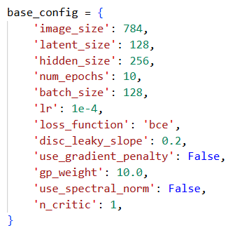
Generator: Maps a latent vector z (in R^d) to a 784-dimensional output (28×28 image).
Discriminator: Maps a 784-dimensional image to scalar probability.
2.2.2 Detailed Desgins
We designed 16 experiments in total in order to have a systematic overview of the affecting factors on GAN training, which are listed as follows:
Experiment | Variable Category | Key Changes | Motivation
exp1_baseline | Baseline | latent=128, lr=1e-4, BCE | Reference configuration
exp2_small_latent | Latent Dim | latent=64 | Lower capacity
exp3_large_latent | Latent Dim | latent=256 | Higher capacity
exp4_elu_activation | Activation | ELU activation | Smooth gradients
exp5_tanh_activation | Activation | Tanh activation | Bounded outputs
exp6_higher_lr | Learning Rate | lr=1e-3 | Faster convergence
exp7_more_epochs | Training Iterations | epochs=80, lr=1e-4 | Extended training
exp8_mse_loss | Loss Function | MSE loss | L2 distance
exp9_wasserstein | Loss Function | Wasserstein loss | Gradient stability
exp10_gradient_penalty | Stabilization | WGAN-GP, n_critic=5 | Enforce Lipschitz
exp11_equal_lr | LR Balance | D_lr=G_lr=2e-4 | Balanced training
exp12_g_larger_lr | LR Balance | G_lr=4e-4, D_lr=1e-4 | Generator priority
exp13_g_smaller_lr | LR Balance | G_lr=1e-4, D_lr=4e-4 | Discriminator priority
exp14_wgan_gp_refined | Advanced | WGAN-GP, epochs=20 | Improved stability
exp15_pure_capacity | Capacity | hidden=512 | More parameters
exp16_capacity_adapted | Capacity | hidden=512, epochs=20 | Adapted training

These experiements are designed to evaluate:
- The effect of Latent Dimensions (Exp 2-3)
- Activation functions (exp 4-5), loss functions (exp 8-9)
- Training Iterations (exp 7), Stabilization (exp 10)
- Variance on LR between G and D models (exp 11-13)
- Model capacity (exp 15-16)
- Latent distance analysis (based on exp1)
- Learning Rate (exp 6)
2.3 Evaluation Metrics
In this assignment, we use FID scores to calculate performance, which measures the distance between feature distributions of real and generated images that are extracted from a pretrained Inception network. Those tested to have a lower FID are considered to have a better quality. FID is computed on 1,000 real and 1,000 generated images in the experiments.
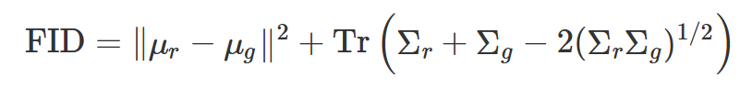
Where:
μᵣ, μ₉: the Mean feature vectors of real/generated data
Σᵣ, Σ₉: Covariance matrices of real/generated data features
Tr(·): Matrix trace (sum of diagonal elements)
(ΣᵣΣ₉)¹ᐟ²: Square root of matrix product
3 Result and Analysis
3.1 Overall Performance
Rank | Experiment | FID Score | Key Experimental Setting
1 | exp1_baseline | 30.53 | Baseline: latent=128, BCE loss
2 | exp2_small_latent | 26.80 | Latent Dimension: 64
3 | exp3_large_latent | 25.70 | Latent Dimension: 256
4 | exp4_elu_activation | 82.05 | Activation: ELU
5 | exp5_tanh_activation | 75.50 | Activation: Tanh
6 | exp6_higher_lr | 30.98 | Learning Rate: 0.001
7 | exp7_more_epochs | 70.57 | Training: 80 epochs
8 | exp8_mse_loss | 24.40 | Loss Function: MSE
9 | exp9_wasserstein_loss | 270.47 | Loss Function: Wasserstein
10 | exp10_gradient_penalty | 40.79 | Stabilization: WGAN-GP
11 | exp11_equal_lr | 55.10 | LR Balance: D_lr=G_lr
12 | exp12_g_larger_lr | 45.32 | LR Balance: G_lr > D_lr
13 | exp13_g_smaller_lr | 48.07 | LR Balance: G_lr < D_lr
14 | exp14_gradient_penalty_improved | 137.12 | Advanced: Refined WGAN-GP
15 | exp15_pure_capacity | 86.14 | Capacity: hidden=512
16 | exp16_capacity_adapted | 63.44 | Capacity: hidden=512 + adjusted LR
Result visualization:
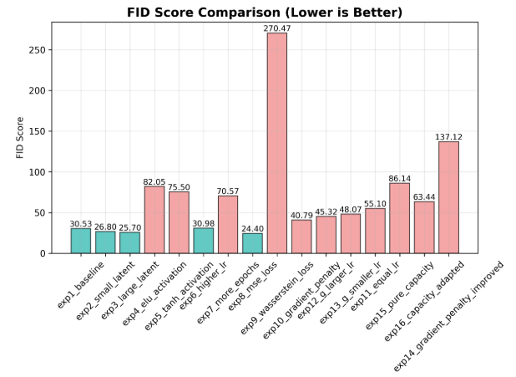
3.2 Training Iterations (exp 7) and Stability Techniques (exp 10)
In this part, we analyzed some of the basic techniques including training iterations and stability techniques analysis. The loss curves are provided to have a more complete view of the training process.
GAN training is highly unstable. Extended training (exp7: 70.57) demonstrated overfitting (baseline:30.53), while basic WGAN-GP (exp10: 40.79) only marginally improved performance compared to exp7. The results suggest that stabilization methods must be carefully integrated, and more iterations don’t always mean a better performance.
Exp 1,7,10 loss curves:
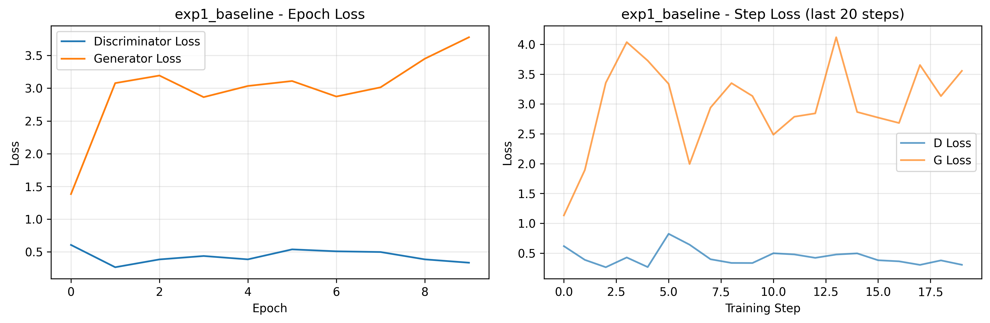
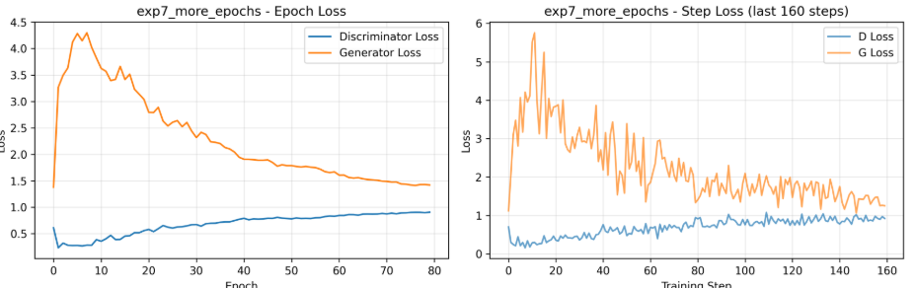
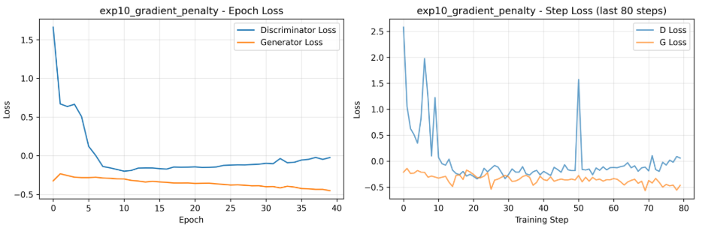
Exp 1,7,10 generated images (though exp 7 images are clearer, some classes in exp7 are wrong or overlapped):
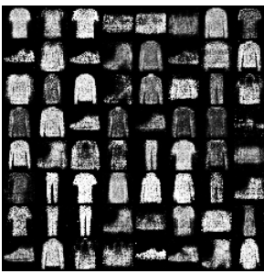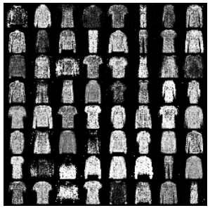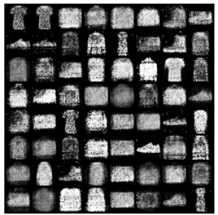
3.3 Latent Space Dimension Analysis (Exp 2-3)
Larger latent spaces (exp3: 25.70) outperformed baseline (exp1: 30.53) and smaller dimensions (exp2: 26.80), indicating enhanced representational ability for the creation of diverse samples. The 256-dimensional latent space provided the best trade-off between training stability and expressiveness. All latent dimension variations performed well, suggesting that extreme dimensional configurations are not required due to Fashion-MNIST's moderate complexity.
Results of experiment 2,3 (clearer doesn’t mean better):
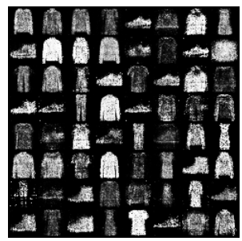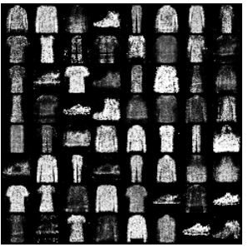
3.4 Activation & Loss Functions (Exp 4-5, 8-9)
While Wasserstein loss (exp9: 270.47) failed entirely, MSE loss (exp8: 24.40) greatly outperformed Tanh (75.50) and ELU (82.05) activations. Though other activations probably experienced gradient vanishing problems, MSE's numerical stability produced smoother gradient signals. This highlights how dependent Wasserstein loss is on complementary stabilization methods.
Exp5 loss curves:
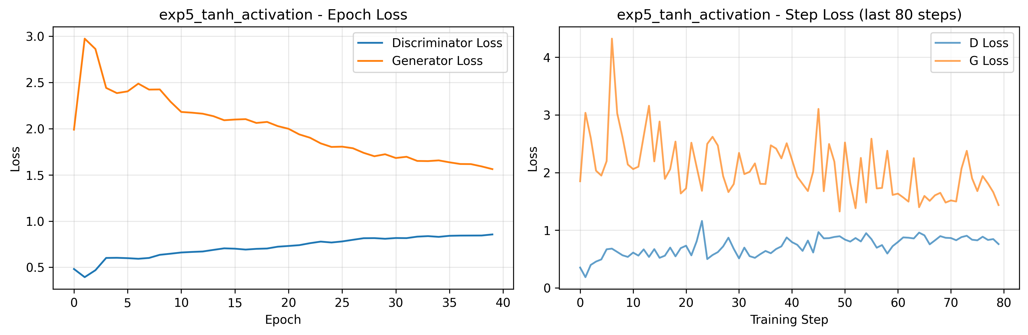
Final Results (exp 4,5,8,9):
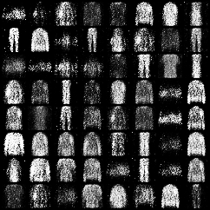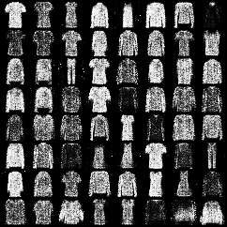
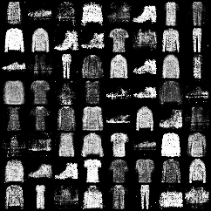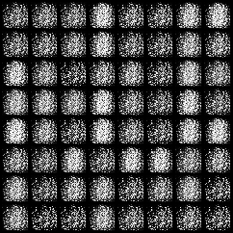
It is easy to observe that experiment 9 image have a large quality gap with the others.
3.4 Latent Distance analysis
GAN assumes real data follows unit Gaussian distribution in latent space. Starting from a far latent vector, the quality of images are poor. We analyzed different latent sizes in every experiment. For example, in exp1_baseline (left image is latent_normal, right image is latent_far), far latent has a worse performance. By far latent vector distance, some of the images very bright and the others blurred, while the normal ones demonstrated a more uniformed and good performance.
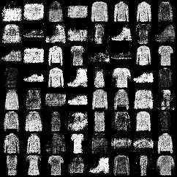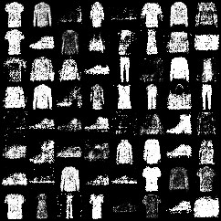
3.5 Variance on LR between G and D models (exp 6,11-13)
The most successful asymmetric learning rates were those with higher generator rates (exp12, G:D_lr=4:1, FID=45.32), demonstrating how important generator’s coping is against the quickly changing discriminators. This is followed by G_lr<D_lr (exp 13,FID=48.07), which don’t influence much compared to exp12, reflecting that maybe GAN is kind of robust on G:D learning rate ratios. Balanced rates (exp11: 55.10) have the worst performance. However, in experiment 6, we increased the learning rate to 1e-3, and it got a good performance with FID 30.98.
Exp 6,11,12:
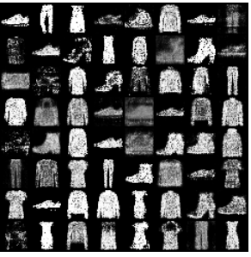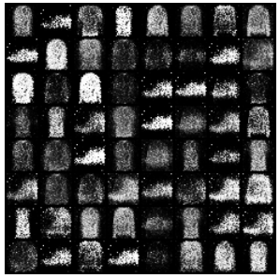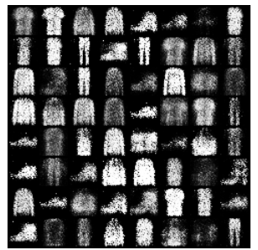
Loss curves:
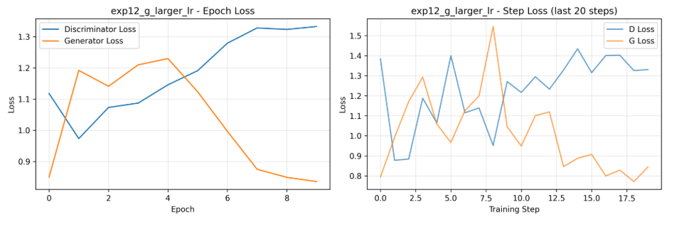
The loss curves showed higher generator learning rate makes the first few steps more unstable, however better in the later steps.
By comparing experiment 6 and baseline learning curves:
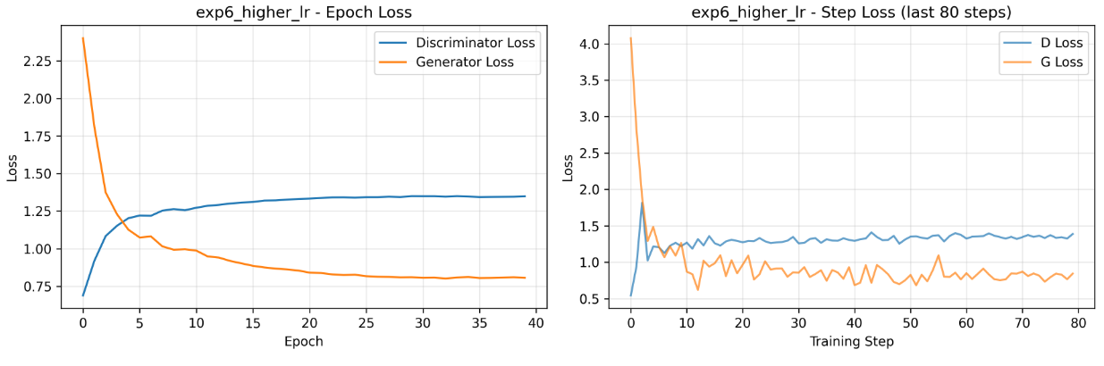
We can see here a larger lr provides a much quicker convergence. However this is not always the same, choosing a good hyperparameter needs more experiments and testing.
3.6 Model capacity (exp 6, 15-16)
Both pure capacity expansion (exp15: 86.14) and adapted capacity (exp16: 63.44) performed not so good compared to some of the best-performing techniques. Performance was negatively impacted by simple hidden size increases, and this is probably due to some over-parameterization. However, if we adjust capacity with a lower learning rate, maybe we can get some improvement.
Exp 15,16 (left to right):
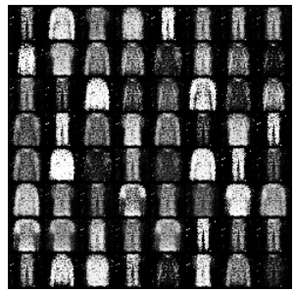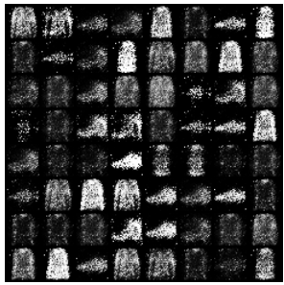
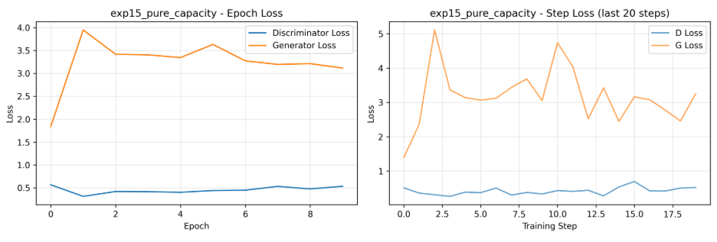
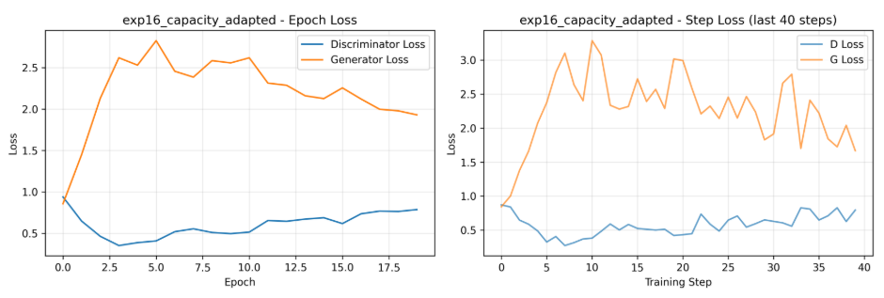

4 Conclusion
In this assignment, we did an overall analysis on some of the probable affecting factors with GAN on MNIST, which includes: activation functions, loss functions, stabilization, learning rate, model capacity, latent vector distance and some other techniques. Results show that most of the methods perform unifromly well, with MSE loss+expanded latent space+asymmetric learning rates (G>D_lr). While Wasserstein loss function has the worst performance, with generated images have a very low quality. Some activation functions like Tanh and Relu also didn’t perform well.
This work shows that GAN is very unstable however with some tachniques properly chosen, it may also provide good results. Adptive training is important in tuning GAN to perform better, a normalized sampling may provide higher-quality images, and incorporating various techniques together might be helpful. All in all, tuning GAN is hard and some modern techniques can be further adopted to make it perform better.

